**Installation of Oracle 11gR2 Client, SQL Developer, Forms, & Reports  
on Boeing Standard Windows 7 64-bit Laptops – June 19, 2011**

This procedure loads the latest Oracle Client Development environment on a Windows 7 64-bit PC. It is intended for programmers who need access to SQL Developer, Oracle Forms, & Oracle Reports but who do not need to install a database instance.

You MUST have admin privs on your PC or you might as well stop right now.

During installation you will be asked to provide your Oracle Support email and password so that Oracle can inform you of security updates. If you elect to provide this information, the installation program will attempt to connect to Oracle. If you are on the Boeing network or are logged into the Boeing network using tunnel mode “tunnel all”, a dialog will appear asking you for proxy information. To avoid this proxy dialog, perform these installations while not logged into the Boeing network or logged in while using tunnel mode “split tunnel”.

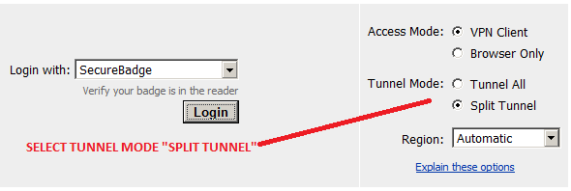

Oracle installs may cause the following dialog to be displayed after installation is complete. The installation was successful if the Oracle installation completed successfully. If and when this dialog appears, press the CANCEL button.

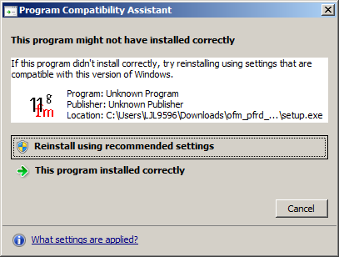

**This Procedure was validated on a Boeing Win7 Standard Tech Laptop:**

OS Name Microsoft Windows 7 Enterprise  
Version 6.1.7600 Build 7600  
System Manufacturer Dell Inc.  
System Model Precision M4500  
System Type x64-based PC  
Processor Intel(R) Core(TM) i7 CPU  
SMBIOS Version 2.6  
Hardware Abstraction Layer Version = "6.1.7600.16385"  
Installed Physical Memory (RAM) 8.00 GB  
Total Physical Memory 7.93 GB  
Available Physical Memory 6.10 GB  
Total Virtual Memory 15.9 GB  
Available Virtual Memory 14.0 GB  
Page File Space 7.93 GB  
Page File C:\pagefile.sys

**Download required files:**

1. Create the c:\temp\ora11 directory
2. Copy down the files from hazdev\oracle\11g\IDS11g2 to your c:\temp\ora11 directory and unzip there.
3. Extract all zip files in the current directory. Afterwards, the directory C:\Temp\ora11\ofm_frmrpts_win_11.1.2.2.0_64 should contain these files and folders: 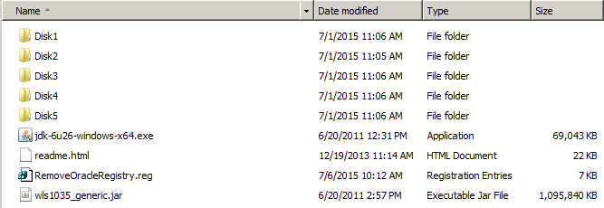
4. Copy ldap.ora, sqlnet.ora, & tnsnames.ora from usseap2.ca.boeing.com:/project/hazmat/sd/hazdev/oracle/11g to your c:\temp\ora11 directory.
5. After all installation steps are complete, you can delete the c:\temp\ora11 directory.

**Uninstall all Oracle Client software:**

1. Open Windows Explorer to directory “C:\Temp\ora11\ofm_frmrpts_win_11.1.2.2.0_64”. Double click on “RemoveOracleRegistry.reg” and click the appropriate yes boxes.
2. Go to Start🡪right click on Computer🡪click on Properties🡪Click on “Advanced System Settings”🡪Click on “Environmental Variables” Button--> In “System variables Delete” modify:
   1. Delete “LD_LIBRARY_PATH” variable
   2. Edit “Path” and remove anything that starts with “c:\Oracle” Example (I use a text editor and replace “;” with “;\n” {semicolon + a new line} and I get this:

C:\Oracle\Middleware\Oracle_FRHome1\bin;

C:\Oracle\12cR1client64bit\bin;

C:\Oracle\12cR1client32bit\bin;

C:\Program Files\Java\jdk1.6.0_26\bin;

C:\Program Files (x86)\SlickEditV18.0.1\win\;

%SystemRoot%\system32;

%SystemRoot%;

%SystemRoot%\System32\Wbem;

%SYSTEMROOT%\System32\WindowsPowerShell\v1.0\;

C:\Program Files (x86)\Common Files\ACD Systems\EN;

C:\Program Files (x86)\Common Files\ACD Systems;

C:\Program Files\Intel\WiFi\bin\;

C:\Program Files\Common Files\Intel\WirelessCommon\;

%HummPATH14%;

%systemroot%\System32\WindowsPowerShell\v1.0\;

c:\Program Files (x86)\Microsoft SQL Server\90\Tools\binn\;

C:\Program Files\McAfee\Solidcore\Tools\GatherInfo;

C:\Program Files\McAfee\Solidcore\Tools\Scanalyzer;

C:\Program Files\McAfee\Solidcore\;

C:\Program Files\McAfee\Solidcore\Tools\ScGetCerts;

C:\Program Files\TortoiseSVN\bin;

C:\Program Files\McAfee\Tools\GatherInfo;

C:\Program Files\McAfee\Tools\Scanalyzer;

C:\Program Files\McAfee\;

C:\Program Files\McAfee\Tools\ScGetCerts;

C:\Oracle\Middleware\Oracle_FRHome1\opmn\bin;

C:\Oracle\Middleware\Oracle_FRHome1\opmn\lib;

C:\Oracle\Middleware\Oracle_FRHome1\perl\bin

* 1. I removed all the lines starting with c:\Oracle and get this:

C:\Program Files\Java\jdk1.6.0_26\bin;

C:\Program Files (x86)\SlickEditV18.0.1\win\;

%SystemRoot%\system32;

%SystemRoot%;

%SystemRoot%\System32\Wbem;

%SYSTEMROOT%\System32\WindowsPowerShell\v1.0\;

C:\Program Files (x86)\Common Files\ACD Systems\EN;

C:\Program Files (x86)\Common Files\ACD Systems;

C:\Program Files\Intel\WiFi\bin\;

C:\Program Files\Common Files\Intel\WirelessCommon\;

%HummPATH14%;

%systemroot%\System32\WindowsPowerShell\v1.0\;

c:\Program Files (x86)\Microsoft SQL Server\90\Tools\binn\;

C:\Program Files\McAfee\Solidcore\Tools\GatherInfo;

C:\Program Files\McAfee\Solidcore\Tools\Scanalyzer;

C:\Program Files\McAfee\Solidcore\;

C:\Program Files\McAfee\Solidcore\Tools\ScGetCerts;

C:\Program Files\TortoiseSVN\bin;

C:\Program Files\McAfee\Tools\GatherInfo;

C:\Program Files\McAfee\Tools\Scanalyzer;

C:\Program Files\McAfee\;

* 1. I then remove the new lines by replacing “;\n” and “;” and put it back in the “PATH”

1. Reboot PC.
2. Delete C:\Oracle folder.
3. Delete C:\Program Files\Oracle folder.
4. Delete the C:\Program Files(x86)\Oracle folder if it exists.
5. Empty the Recycle Bin.
6. Go to Start🡪”All Programs” and delete all Oracle folders

**Uninstall SQL Developer:**

1. Delete the C:\Program Files\sqldeveloper folder and/or the C:\Program Files(x86)\sqldeveloper folder.
2. Delete any associated Start Menu shortcuts

**Install “Oracle Database Client 12c”:**

1. Run Software Express. Go to **“Common Authorized Business Software”🡪M-R Catalog🡪Oracle**.

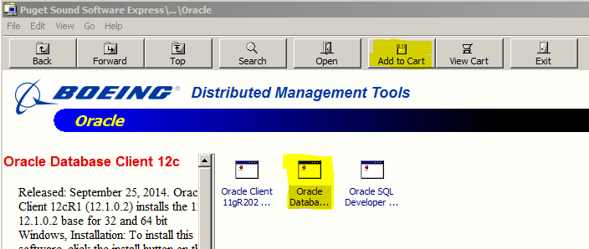

1. Select “Oracle Database Client 12c” and click “Add to Cart”
2. Press START button in the Software Cart dialog.

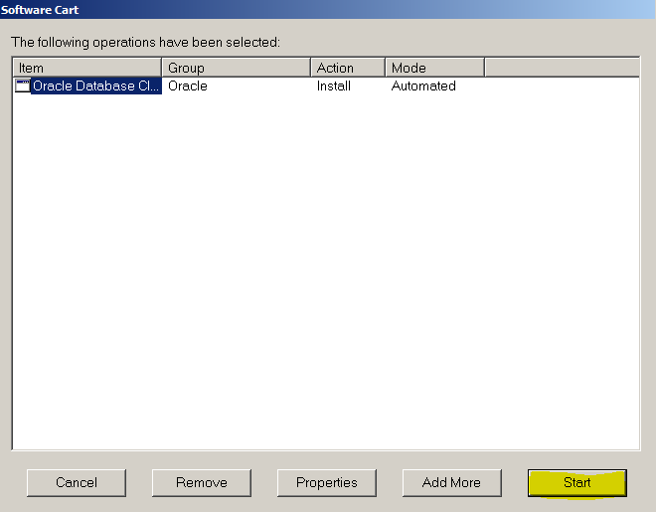

1. If any boxes come up that REQUIRE an acknowledgement, then do so. My experience had no such boxes.

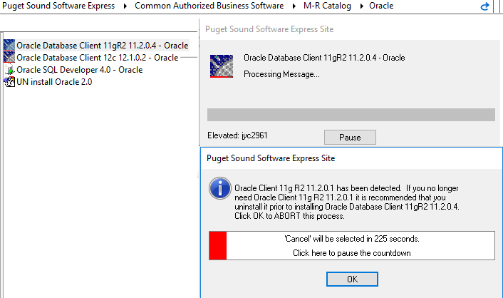

**Install Java SDK & JRE:**

1. If you already have this installed, then skip this installation.
2. cd C:\Temp\ora11\ofm_frmrpts_win_11.1.2.2.0_64
3. Double-click on jdk-6u26-windows-x64.exe to start the Java installation.
4. Press RUN on the Open File - Security Warning dialog.

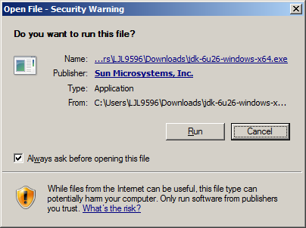

1. Press NEXT on the Setup Welcome dialog.

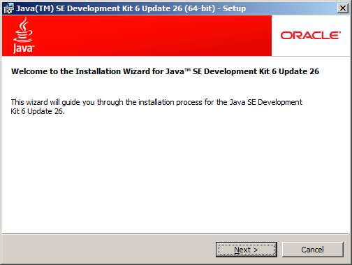

1. Press NEXT on the Program Features dialog.  
   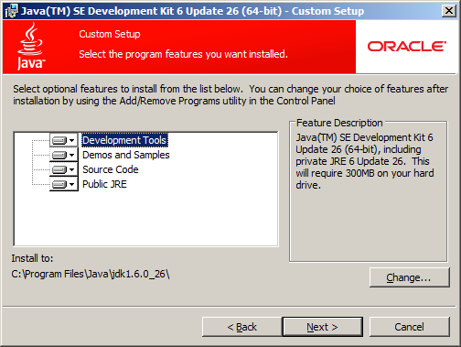
2. Wait for installation to complete. No action is required during installation process.  
   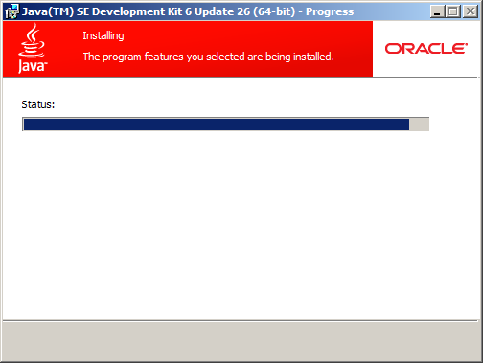
3. Press FINISH when installation is complete. A browser window will open for registration. This can be closed.  
   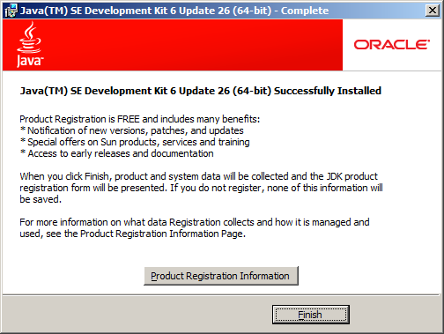

**Install Web Logic Server:**

1. In the c:\temp\ora11 folder, double click on “cmd.exe” shortcut
2. Click “Yes” to the popup asking “Do you want to allow changes to this computer?”.
3. cd C:\Temp\ora11\ofm_frmrpts_win_11.1.2.2.0_64
4. Run wls1035_generic.jar.
5. Press the NEXT button on the Welcome dialog.  
   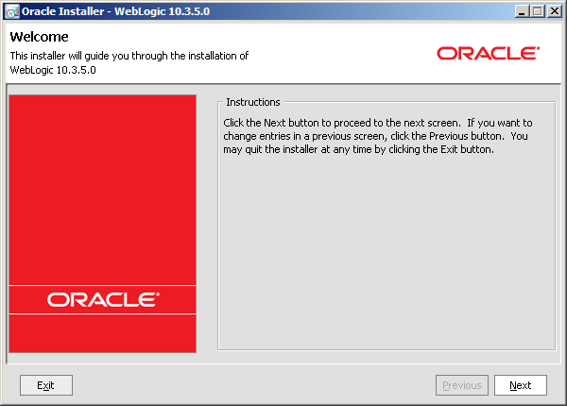
6. Press the NEXT button to accept the directory C:\Oracle\Middleware on the Middleware Home Directory dialog.  
   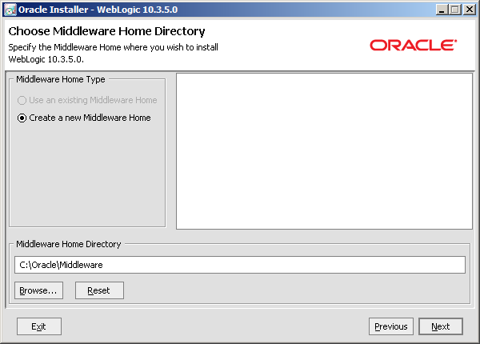
7. You can enter your Oracle Support email and password and press NEXT , or just click NEXT and then “Yes” on the next 2 popup boxes.  
   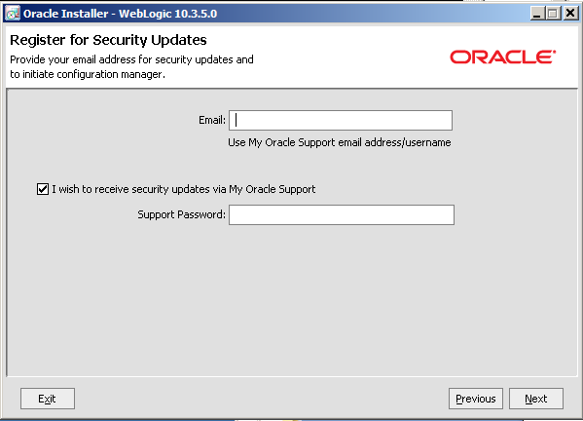
8. Check the “I wish to remain uninformed…” and press the “Continue” button on the install type dialog.  
    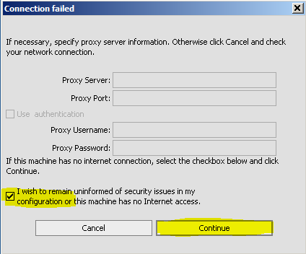
9. Press the NEXT button on the install type dialog.  
   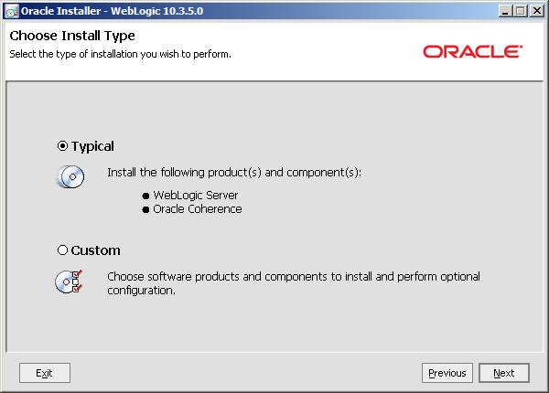
10. On the JDK selection dialog, browse to the location of the JDK folder (C:\Program Files\java\sdk1.6.0_26) and press the NEXT button.  
    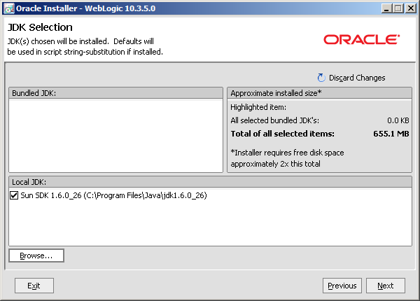
11. Press the NEXT button on the Product Installation Directories dialog (make sure they match to the picture).  
    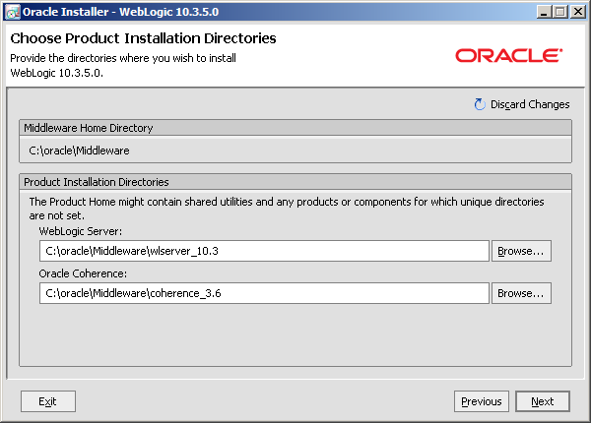
12. Press the NEXT button on the Shortcut Location dialog.  
    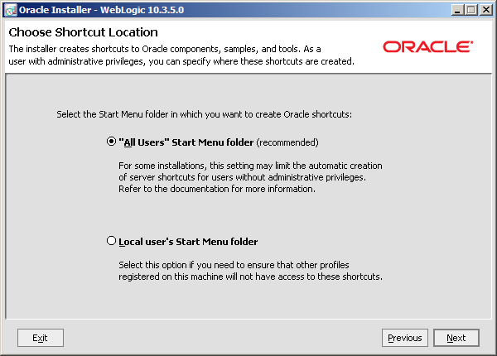
13. Press the NEXT button on the Installation Summary dialog.  
    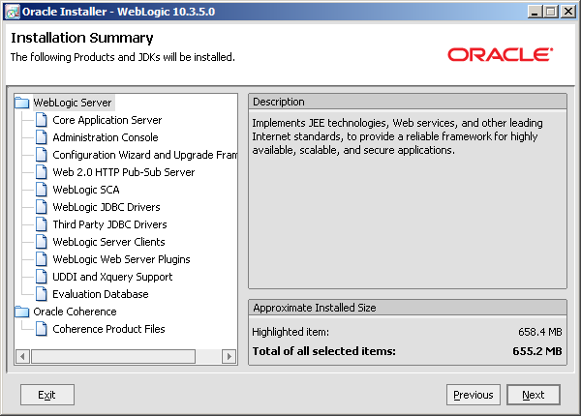
14. Wait for installation to complete. No further action is required while software is installing.  
    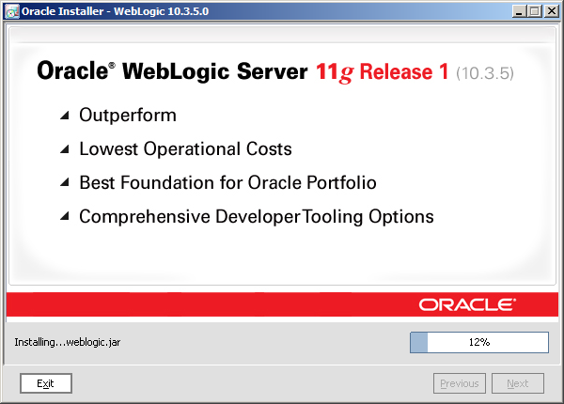
15. When installation is complete, uncheck the “Run Quickstart” checkbox and press the DONE button.  
    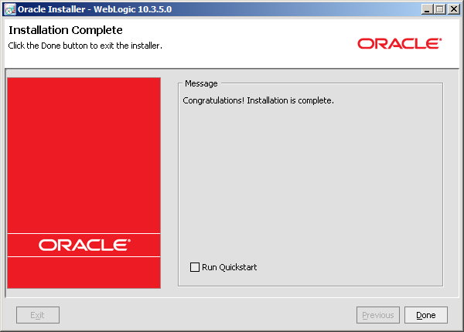
16. **Reboot your PC.**

**Install Oracle Fusion Middleware:**

1. In the c:\temp\ora11 folder, double click on “cmd.exe” shortcut
2. Click “Yes” to the popup asking “Do you want to allow changes to this computer?”.
3. cd C:\Temp\ora11\ofm_frmrpts_win_11.1.2.2.0_64\disk1 folder.
4. Run setup.exe.
5. A DOS window will briefly open to invoke the installer. No action is required to close this window.  
   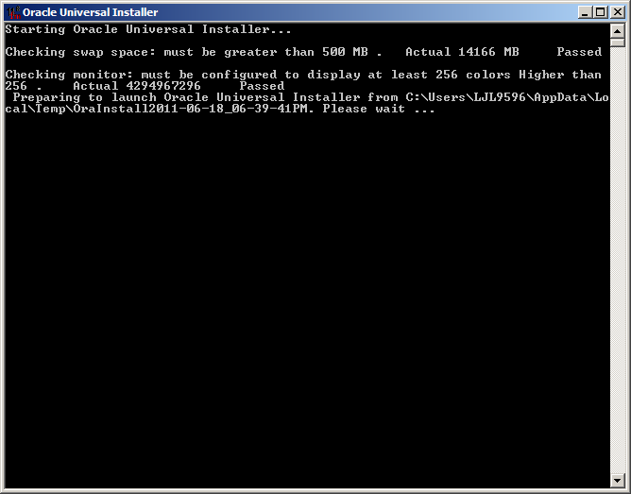
6. Click “Skip Software Updates” radial button and click NEXT.  
   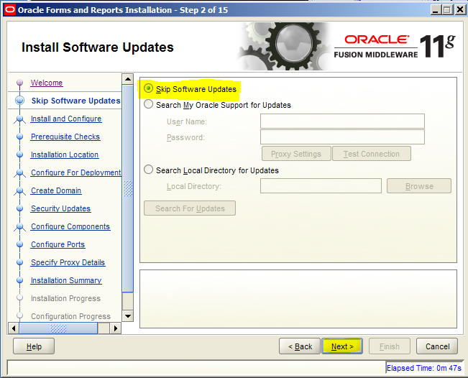
7. Press NEXT on the Welcome dialog.  
   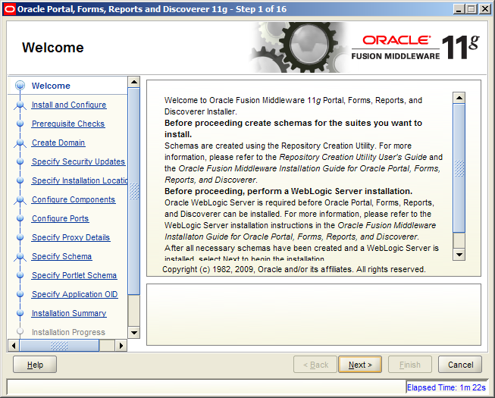
8. Click on the “Install and Configure” radio button and press the NEXT button on the Installation Type dialog.  
   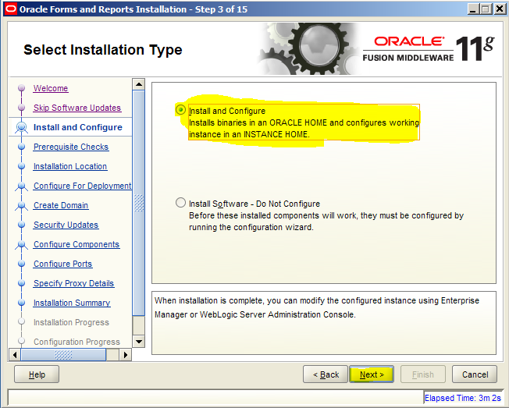
9. After checks complete, press the NEXT button on the Prerequisite Checks dialog.  
   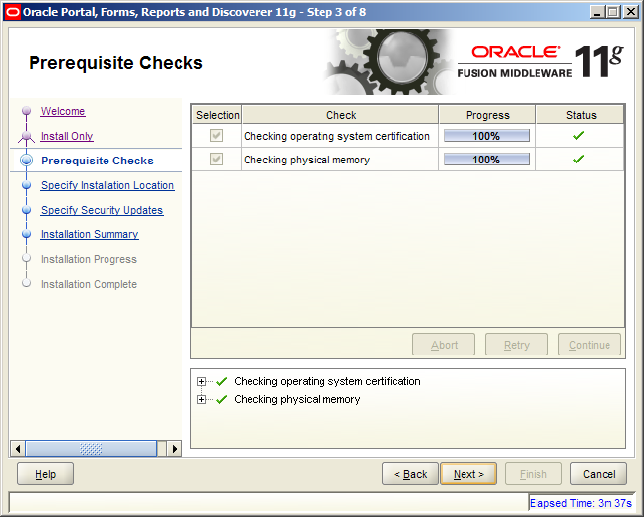
10. Press the NEXT button on the Installation Location dialog.  
    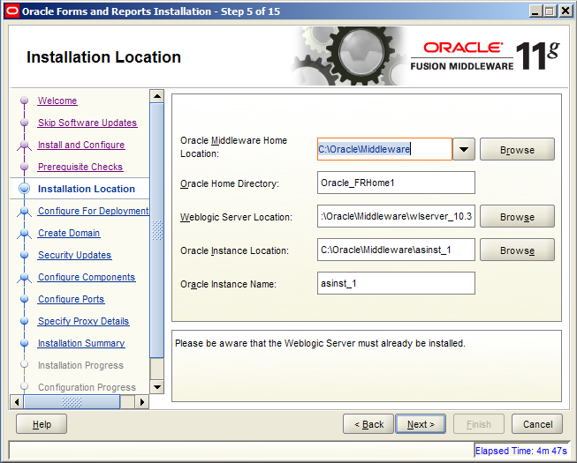
11. Press the NEXT button on the Configuration Type dialog.  
    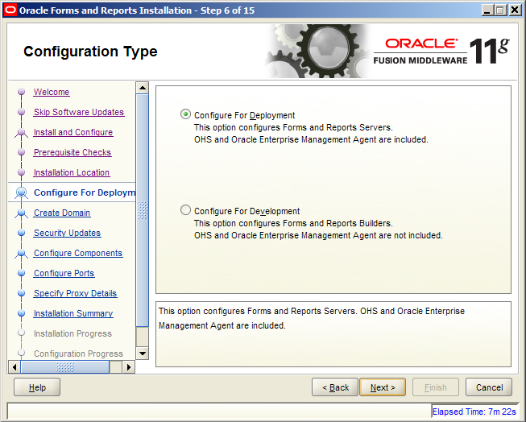
12. On the “Select Domain” screen, put in the password Zipper00 into the 2 password fields, and click NEXT.  
    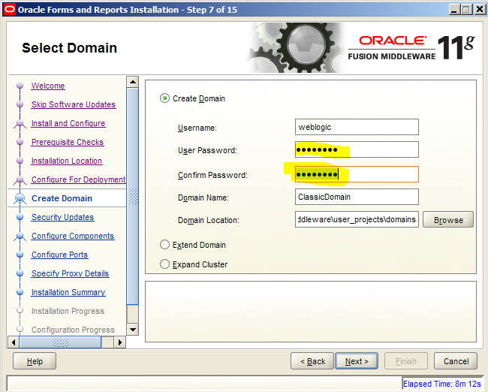
13. You can enter your Oracle Support email and password and press NEXT , or uncheck “I wish to ..” and click NEXT and then “Yes” on the next popup box.  
    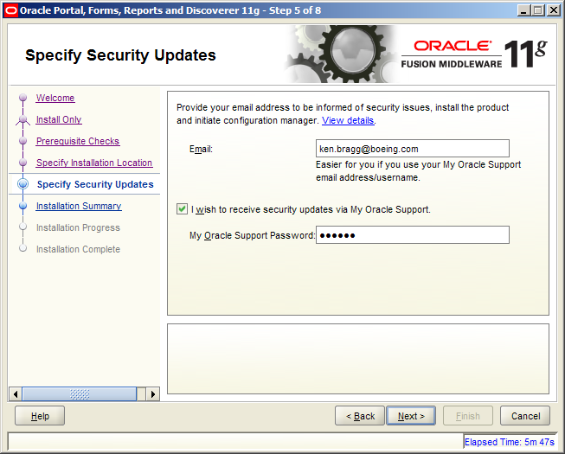
14. On the “Configure components” screen, make sure the top checkbox is checked. Uncheck the “clustered” check box and click NEXT.   
    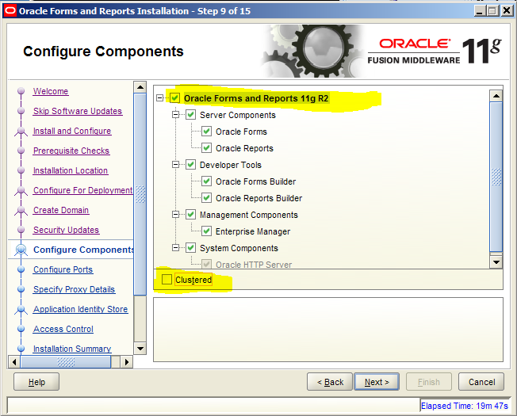
15. Click Next on the “Configure Ports” screen.  
    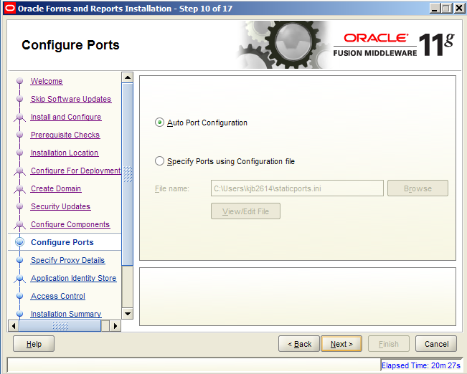
16. Click Next on the “Specify Proxy Details” screen.  
    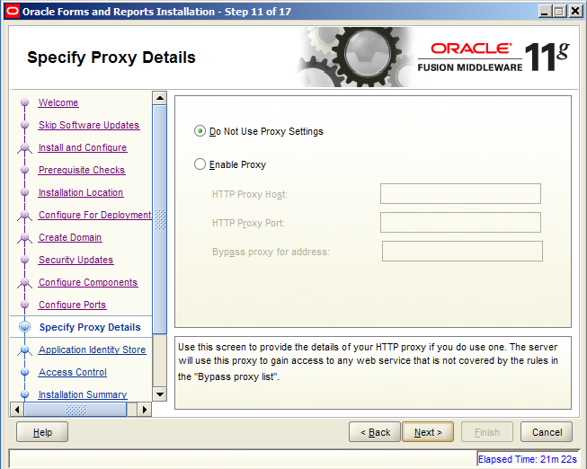
17. Uncheck the “Use Application Identity Store” and click Next  
    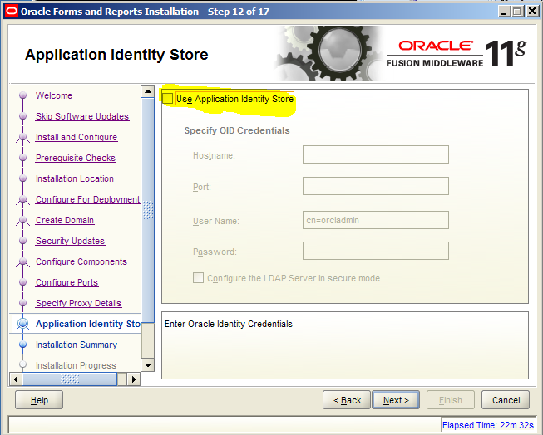
18. Press the INSTALL button on the Installation Summary dialog.  
    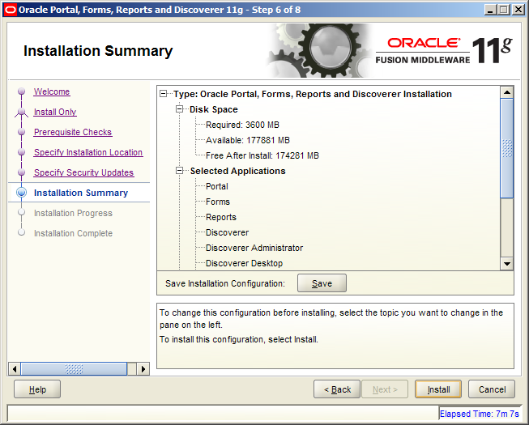
19. Installation begins.  
    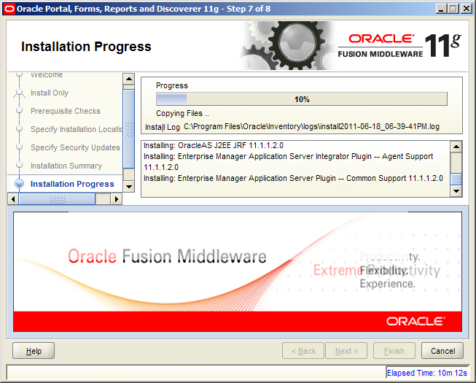
20. Press the NEXT button on the Installation Progress dialog when installation is complete.  
    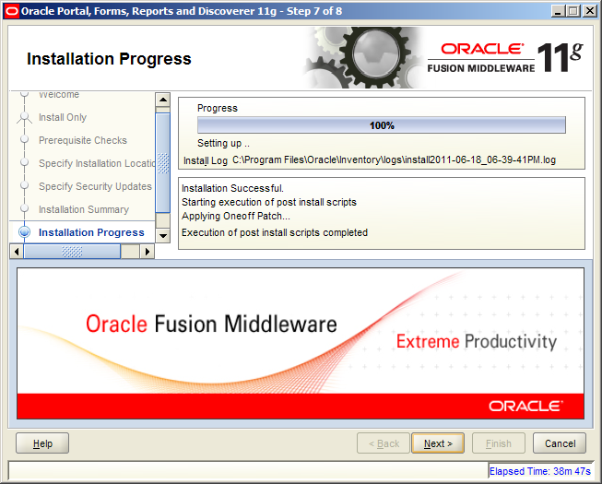
21. Press the Next button on the “Configuration Process”  
    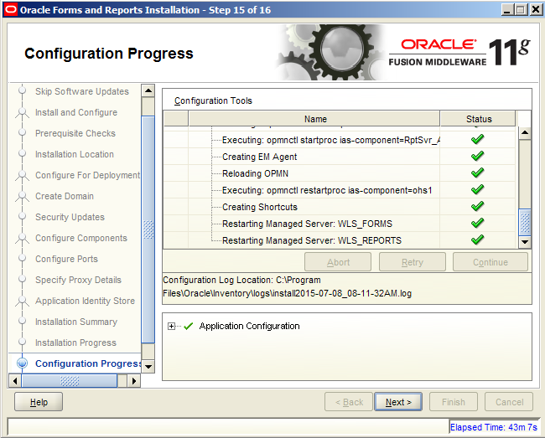
22. Press the FINISH button on the Installation Complete dialog.  
    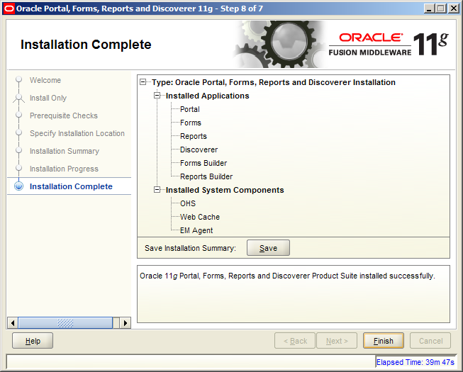
23. Close the cmd window

**Configure Network Connections:**

1. Copy C:\Oracle\12cR1client32bit\network\admin ldap.ora and sqlnet.ora to C C:\Oracle\Middleware\Oracle_FRHome1\network\admin.

**To Show Icons:**

Copy *.gif, *.ico C:\Oracle\Middleware\Oracle_FRHome1\forms\java

**To Get Forms configured for C:\Hazmat:**

1. Cd C:\Oracle\Middleware\user_projects\domains\ClassicDomain\config\fmwconfig\servers\WLS_FORMS\applications\formsapp_11.1.2\config
2. Edit default.env
3. Update FORMS_PATH to:  
   FORMS_PATH=c:\Hazmat;C:\Oracle\Middleware\Oracle_FRHome1\forms;C:\Oracle\Middleware\asinst_1\FormsComponent\forms
4. Save and close
5. Edit formsweb.cfg
6. Update form= to:  
   form=logon.fmx connect_to=select
7. Update width= to:  
   width=1000
8. Update height= to:  
   height=800
9. Update lookAndFeel= to:  
   lookAndFeel=Generic
10. Save and close
11. cd C:\Oracle\Middleware\user_projects\domains\ClassicDomain\bin
12. Edit startWebLogic.cmd and after   
    SETLOCAL

add the following 2 lines:

set WLS_USER=weblogic  
set WLS_PW=Zipper00

1. Save and close
2. Reboot PC

**To Fix Reports Startup Error:**

1. Cd C:\Oracle\Middleware\asinst_1\config\FRComponent\frcommon\tools\admin
2. Edit cauprefs.ora with text editor
3. Find Reports.PluggableDataSourceFactories
4. Change   
   Reports.PluggableDataSourceFactories =  
   ("oracle.reports.plugin.datasource.xmlpds.XMLDataSourceFactory",  
    "oracle.reports.plugin.datasource.jdbcpds.JDBCDataSourceFactory",  
    "oracle.reports.plugin.datasource.textpds.TextDataSourceFactory")  
     
   with  
     
   Reports.PluggableDataSourceFactories = ()
5. Save

**To run HazTrax Locally:**

1. Go to **Start🡪All Programs🡪Oracle Classic Instance - asinst_1🡪Start Weblogic Admin Server** , and then wait (a long while) until the dos window stops at “RUNNING mode>”
2. Go to **Start🡪All Programs🡪Oracle Classic Instance - asinst_1🡪Forms Services🡪Start Weblogic Server - WLS_FORMS** , and then wait (a long while) until the dos window stops at “RUNNING mode>”
3. If either of the windows closes, you didn’t follow the instructions correctly.
4. If all went well, you can start Haztrax at:  
   <http://localhost:9001/forms/frmservlet>
5. If you hate Ken, take it out on Paul.

**To Create Shortcuts:**

1. Go to **Start🡪All Programs🡪Oracle Classic Instance - asinst_1🡪Developer Tools** , and then on Forms Builder, Right Click and select “Copy”
2. Then click 1 time in a blank area of your desktop, the right click on desktop and select “Paste”
3. Right click on the new shortcut created, and select “Properties”
4. Change this to c:\hazmat
5. Click “Ok”
6. For Reports, repeat same action on **🡪All Programs🡪Oracle Classic Instance - asinst_1🡪Developer Tools** , and then on “Start Reports Builder”
7. You’ve got Shortcuts

**To Make your Local Forms Environment:**

1. Open a windows explorer window to c:\hazmat and delete the forms and libraries directories
2. Open a windows explorer window to \\usseap12.ca.boeing.com\haztest\versions and select the newest directory grab the forms.zip and extract to your temp directory
3. Grab the “forms” and “libraries” directories and copy them to c:\hazmat
4. Bring up Forms Builder, Open File c:\hazmat\libraries\haztrax.pll
5. Compile (Ctrl-Shift-K or Program🡪Compile PL/SQL🡪All) and then disconnect and then save.
6. Open a windows explorer window to c:\hazmat\notes and double click on hazbuild
7. It will take 2 minutes to 30 minutes to compile depending on your connection speed.
8. You now have a build directory in c:\hazmat where all your development is done!